

**Bangladesh University of Business and Technology (BUBT)**

Course No. : **CSE - 465**

Course Title: **Machine Learning**

Semester: **Summer 2022 [Tri-Semester]**

Survey Paper Name: SkinNet-16: A deep learning approach to identify benign and malignant skin lesions

**Submitted by -**

Name: Abu Zobayer Bin Siddique

ID: 18192103226

Name: Ahmed Mahir Shoaib

ID: 18192103235

Name: Shoibal Das

ID: 18192103252

Name: All Moon Tasir

ID: 18192103256

Name: Poonam Tabassum

ID: 18192103259

**Submitted to -**

**Khan Md. Hasib**

**Faculty Member, Department of CSE, BUBT**

**Summary of the Paper:** In the current era, skin cancer has emerged as one of the most prevalent cancers. SkinNet-16, a deep learning classifier, has a learning rate of 0.006. The neural network-based model produced in this study's Adamax optimizer has a remarkable accuracy of around 99.19%. In the year 2020, skin cancer was the fourth most frequent cancer. Australia and New Zealand have the highest recorded rates of skin cancer. Skin cancer can be detected early by a dermatologist. Early detection minimizes morbidity, lowers healthcare costs, and increases patient survival rates.

**Unique Contribution of the Paper:** The original dataset was used to choose all of the pictures that were selected for the study. The PCA feature selection approach was used to cut the dimensionality in half to create the impacting feature set (10 features). Their developed SkinNet-16 classifier, a generalized model with no overfitting, is based on a convolution neural network (CNN) and is used to detect skin lesions.

**How the proposed model works in the paper:** A Convolutional Neural Network (ConvNet/CNN) is a Deep Learning system that can take in an input picture, give relevance (learnable weights and biases) to various aspects/objects in the image, and distinguish between them. In comparison to other classification techniques, the amount of pre-processing required by a ConvNet is significantly less. While basic approaches require hand-engineered filters, ConvNets can learn these filters/characteristics with enough training.

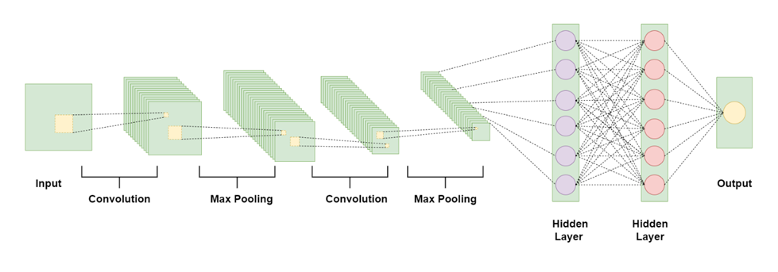

The neural network SkinNet-16 SkinNet-16 is a convolutional neural network (CNN) model and a subset of the ANN model. To enhance accuracy, the majority of deep learning algorithms employ many layers of artificial neurons. Such extensive processing, however, necessitates a higher memory and processing footprint from the hardware. Furthermore, the usage of optimizers assisted us in optimizing the learning rate to decrease losses. For example, Adam computes adaptive learning rates for each parameter, making it the fastest algorithm to converge to minima; Nesterov-accelerated adaptive moment estimation (Nadam) usually outperforms Adam, though this depends on the model; the stochastic gradient descent (SGD) algorithm derivative is computed one point at a time, requiring significantly less memory; and Adamax is known for its robustness to gradient update noise and having better numerical stability.

CNNs are the most widely used deep learning algorithms, outperforming their predecessors in the identification of significant characteristics. Its approaches have been accepted for several imaging classifications due to their high accuracy. We previously observed similar extraordinary accuracy in the diagnosis of malignant tumours using deep CNN. Andre Esteva's, Rehan Ashraf et al .'s, and Manu Goyal et alstudies .'s demonstrated the superiority of CNN as a classifier, prompting them to use CNN in their method.

**Advantages of the paper:** The study makes use of two well-known datasets that are freely available to the public. To assess its performance, the suggested deep learning model is applied to both datasets. The recorded performance metrics show that the new model has consistent and high accuracy when applied to both datasets. Furthermore, this model generates the results displayed in the shortest period of time.

**Disadvantages of the paper:** There are seven different types of skin lesions in the HAM10000 dataset. In the skin, however, we used binary classification to distinguish solely the malignant and benign classes. At the same time, it is well understood that every machine learning technique requires a substantial amount of data to train the model. The datasets included in the study, on the other hand, contain a restricted amount of picture data to train the suggested model.

**Conclusion:** A unique method for identifying skin cancer was proposed in this research. First and foremost, we downloaded their dataset from the Kaggle website. The DHR algorithm was then used to remove hairs from the pictures, and the rolling ball approach was used to reduce background noise, both of which resulted in considerable noise reduction. We used five image filters to create noise-free, unambiguous pictures for further processing on these 3,297 photos, with the mean filter performing best across all criteria. The piecewise linear transformation (PLT) image enhancement approach produced the best results after applying all five filters based on PSNR, MAE, SSIM, and histogram analysis to ensure that picture quality was not compromised. We were able to choose the relevant and correct region in the image thanks to the color coding and ROI-based method. We used morphological operations such as dilation, erosion, and morphological gradient to get the required picture results, and we examined both geometrical and textural aspects using 20 distinct parameters. We discovered that PCA was an effective dimensionality reduction approach in this situation, and we utilized it for feature selection, yielding 10 input features for further analysis. The SkinNet-16 model, a modified version of CNN utilized for skin lesion projection, was employed. This prediction was created by using five separate optimizers and two different learning rates. Based on the Adamax optimizer with a learning rate of 0.006 and more than 98% sensitivity and specificity, this intelligent system obtained an overall accuracy of 99.19% on the ISIC dataset, which is much higher than previous studies and an indicator of the usefulness of the proposed system. As a result, it appears to be a potential method for detecting skin lesions at an early stage.